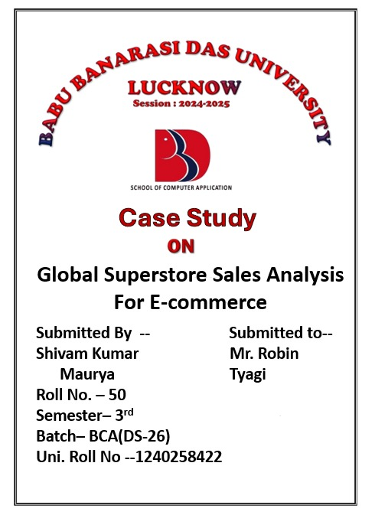

**Global Superstore Data Analysis 📊**

**Agenda/Definition:** The agenda is to **analyse sales performance, profitability, and logistical efficiency** across different product categories, customer segments, and geographical regions. This involves defining key metrics like **Sales, Profit, Quantity, and Shipping Cost**.

**Outcomes/Learning:** Outcomes will include identifying the **most profitable products and customer segments**, the **best and worst performing regions/markets**, and the impact of **Discount and Ship Mode** on profit.

**Required Tool: IBM Cognos Analytics** is required for data manipulation, calculation, and visualization.

**Working:** It involves summarize data by Category, Region, and Segment, calculating **profit margins**, and creating **visualizations** (e.g., charts, graphs, maps, tables) to highlight trends and anomalies.

1. Open IBM Cognos & click on Launch.

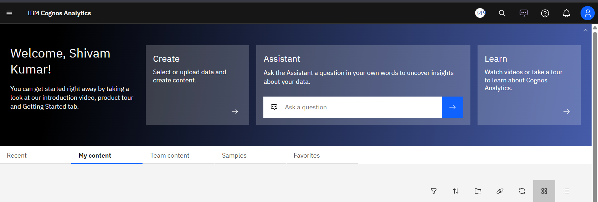

1. Firstly, upload your dataset.

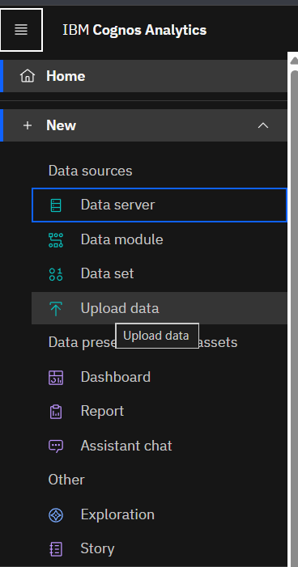

1. Now, click on new & select Dashboard.

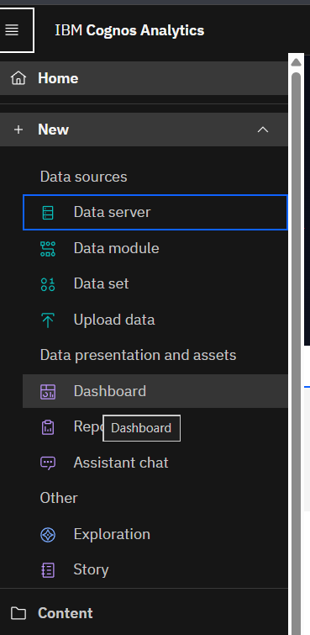

1. Select a template for your Dashboard then Create.

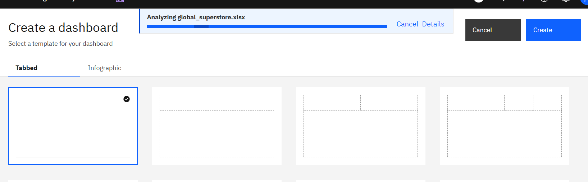

1. Now select a source to add data for creating a dashboard.

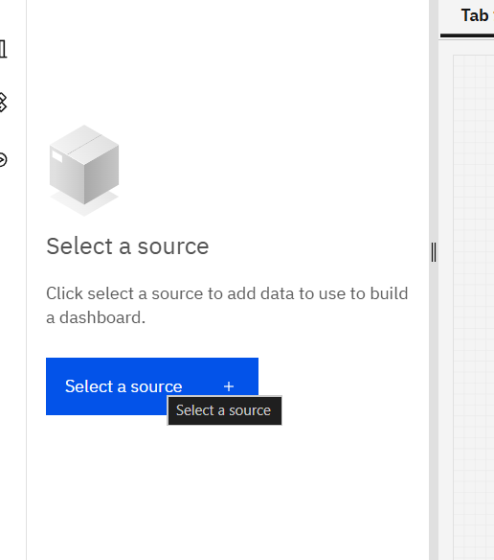

1. Select your source from my content. 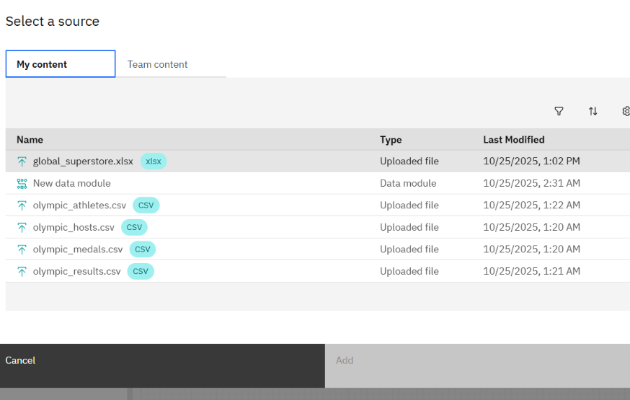
2. Now your source is loaded.

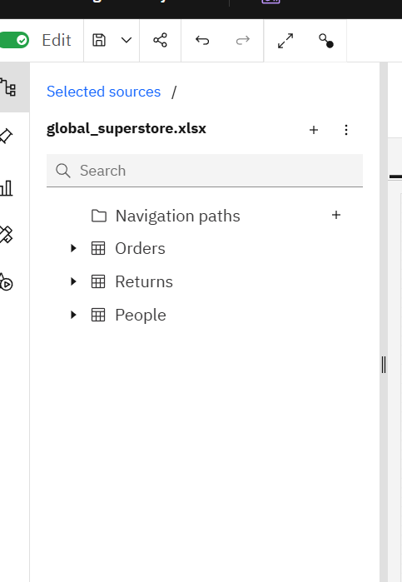

1. Now adding a text box & two shape on this tab from widgets. 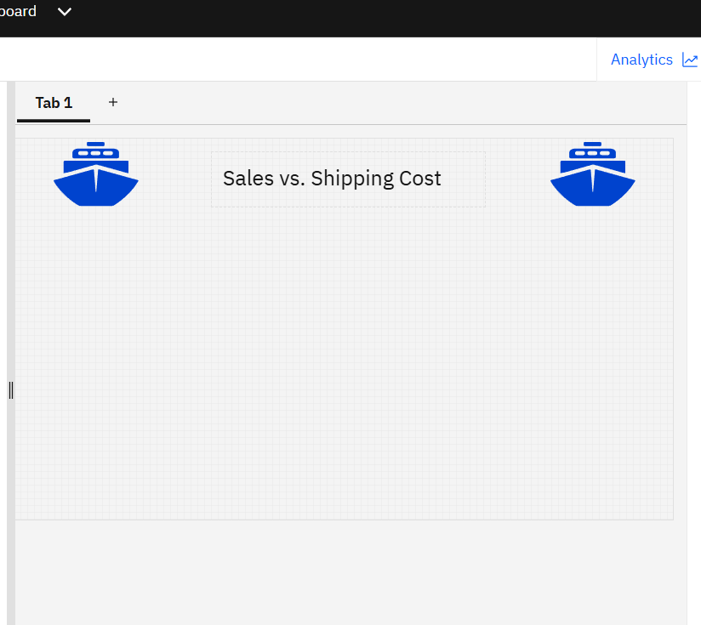

This step is about sales, shipping cost & order date. So, heading is given as

“Sales vs. Shipping Cost”.

Two ship shapes are also used from widgets on both sides.

1. Now adding a Dual Axes Line & Column from visualizations. 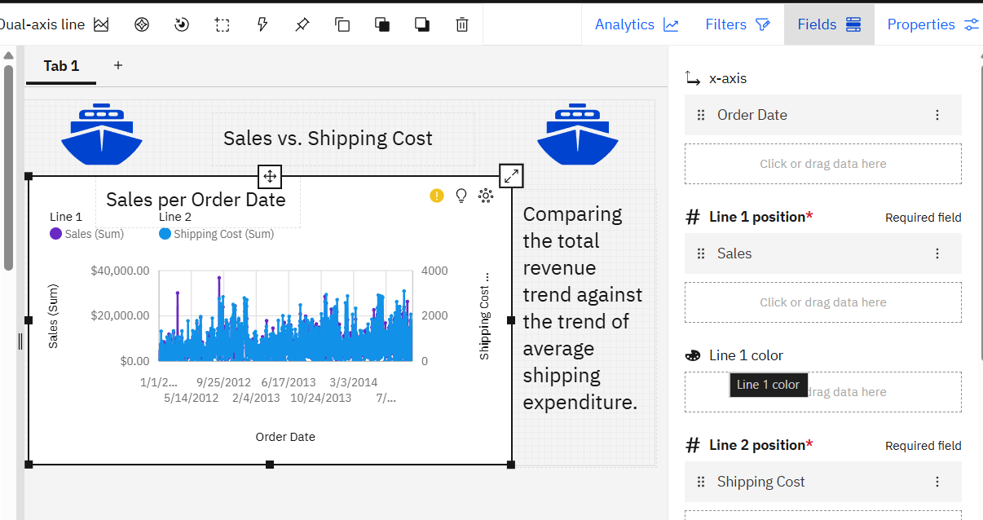

This tab also includes a narrative inside of about Dual Axes Line & Column with a title

“Sales per order date.

**X-Axis (Time):** Order Date.

**Y-Axis 1 (Line1):** Sales (Sum).

**Y-Axis 2 (Line2):** Shipping Cost (Average).

1. Now adding a text box & two badge ribbon on this tab from shapes.

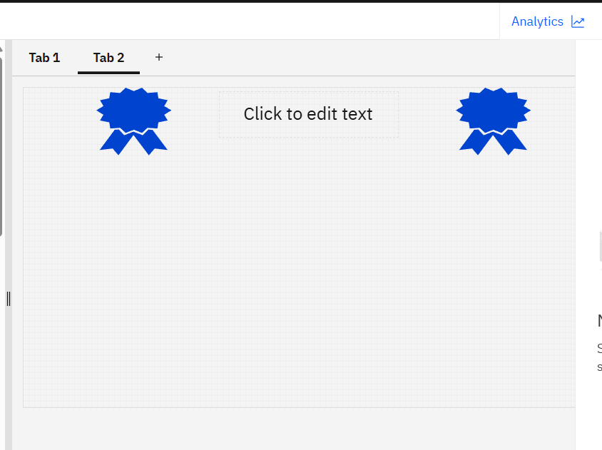

This step is about sales, market & category. So, heading is given as

“Market Contribution” in the empty text box.

Two badge ribbon shapes are also used from widgets on both sides.

1. Now adding a Stacked Column Chart from visualizations.

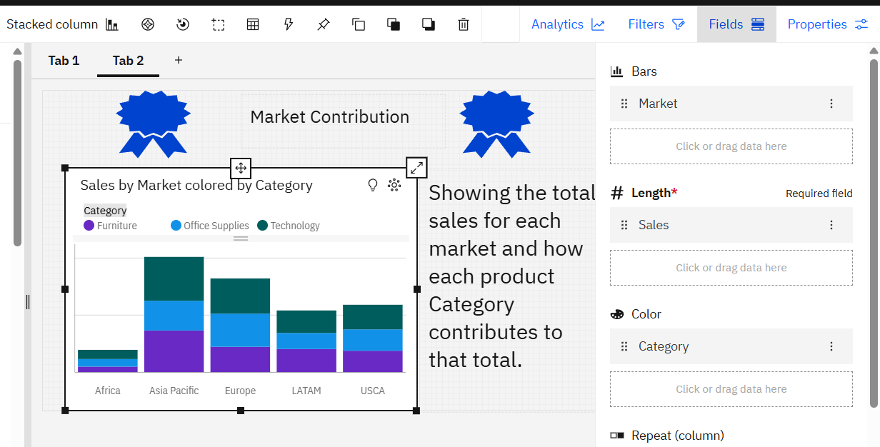

This tab also includes a narrative inside of about Stacked Column Chart with a title of “Sales by Market coloured by Category”.

**Bars:** Market.

**Length:** Sales (Sum).

**Color:** Category.

1. This step is about adding a text box & two money coin shapes on this tab.

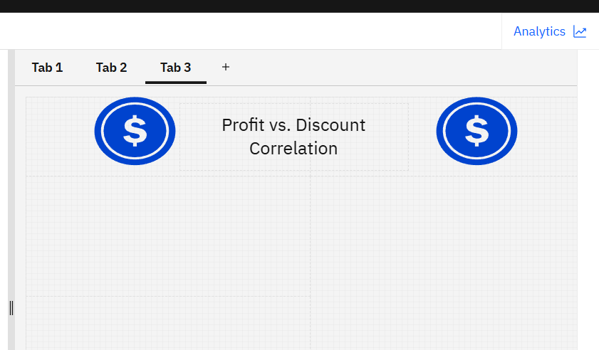

This step is about discount, profit & product name. So, heading is given as

“Profit vs. Discount Correlation”.

Two money coin shapes are also used from widgets on both sides.

1. Now adding a Scatter Chart from visualizations.

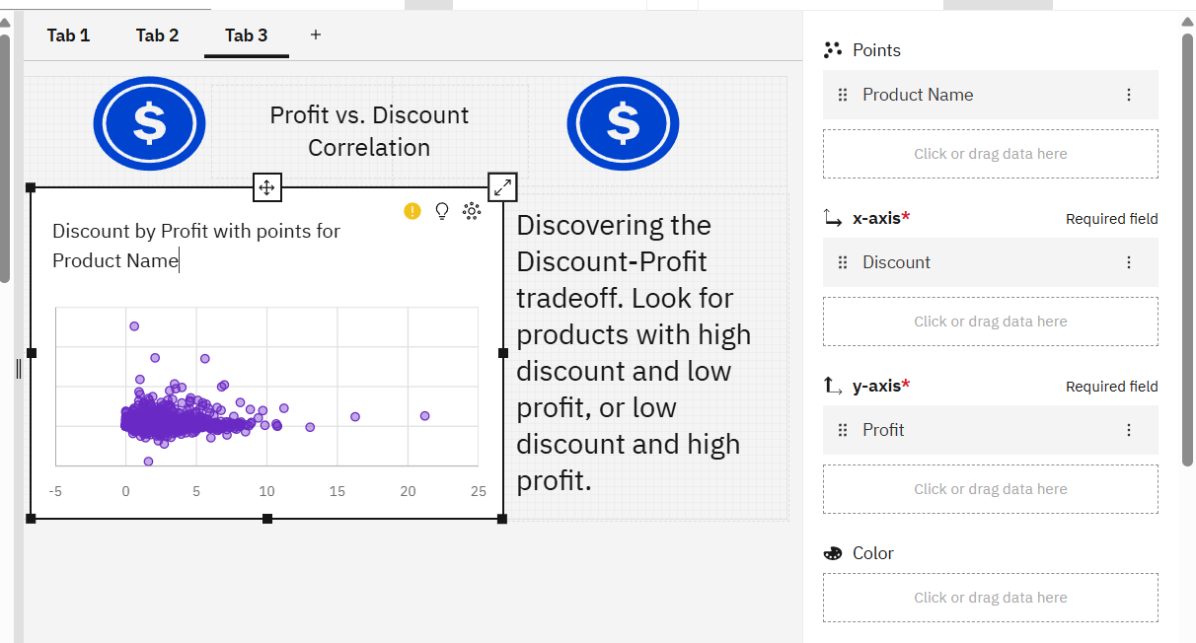

This tab also includes a narrative inside of about Scatter Chart with a title of “Discount by Profit with points for Product Name”.

**X-Axis:** Discount (Average).

**Y-Axis:** Profit (Sum/Average).

**Points:** Product Name

1. This step is about adding a text box & a trending up & down shapes on this tab.

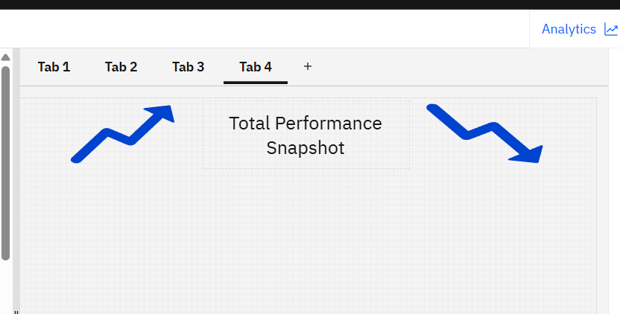

This step is about sales, profit & ship date. So, heading is given as “Total Performance Snapshot”.

Two trending up & down shapes are also used from widgets on both sides.

1. Now adding a KPI (Key Performance Indicator) from visualizations.

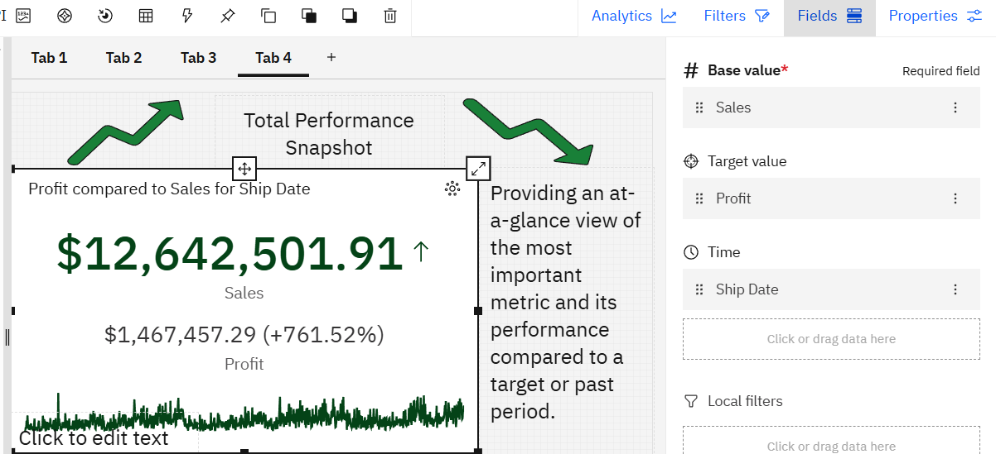

This tab also includes a narrative inside of about KPI (Key Performance Indicator) with a title of “Profit compared to Sales for Ship Date”.

**Base Value:** Sales (Total)

**Target value:** Profit (Total)

Time: **Ship Date** (requires time intelligence features).

1. Now adding a text box & two airplane shapes on this tab from shapes.

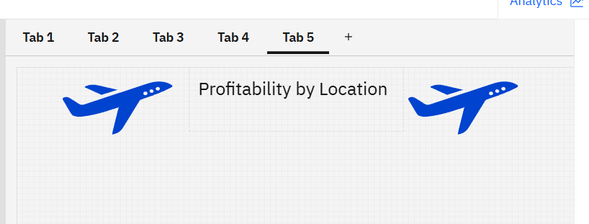

This step is about region & profit. So, heading is given as “Profitability by Location”

Two airplane shapes are also used from widgets on both sides.

1. Now adding a Map from visualizations.

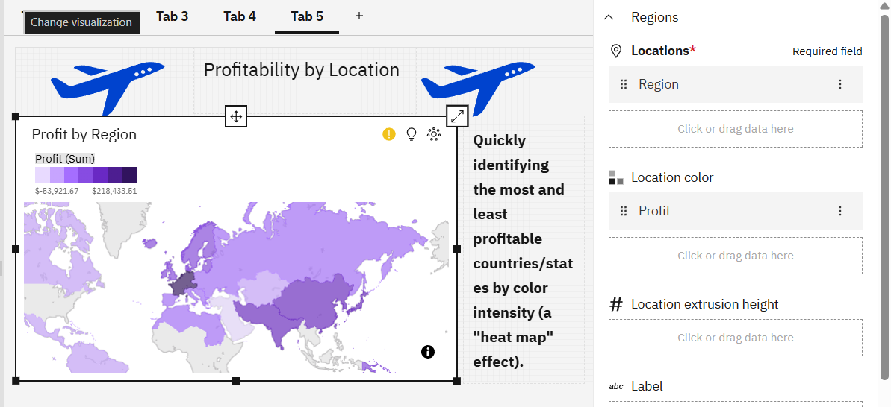

This tab also includes a narrative inside of Map with a title of “Profit by Region”.

**Location Slot:** Country or Reion.

**Color/Heat Slot:** Profit (Sum).

Insights like **Region** **Western Europe** has the highest values of both **Profit** and **Quantity**.

1. Now adding a text box & two shapes on this tab from widgets.

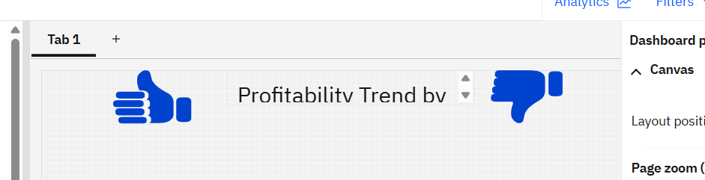

This step is about order date, segment & profit. So, heading is given as “Profitability Trend by Segment”.

Two thumb up & down shapes are also used from widgets on both sides.

1. Now adding a Line chart from visualizations. 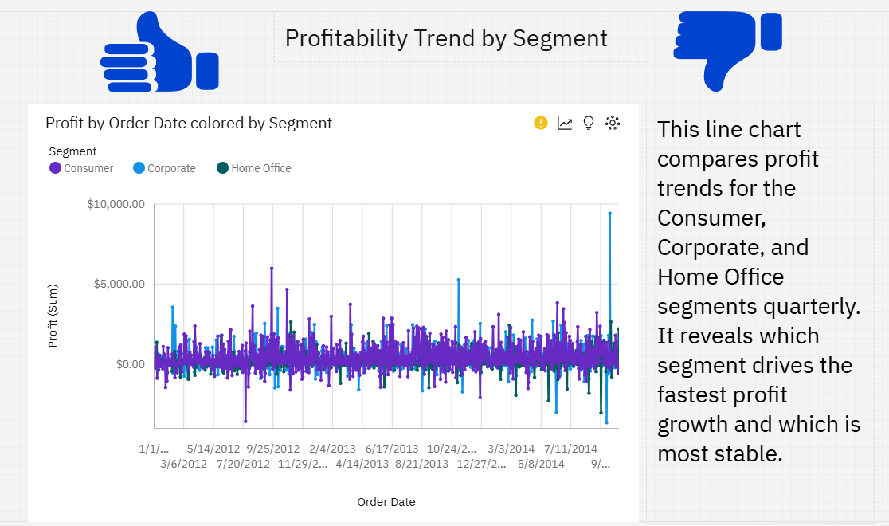

This tab also includes a narrative inside of Line chart with a title of “Profit by Order Date coloured by Segment”.

**Order Date** (Grouped by Quarter)

**Series/Color:** **Segment**

**Y-Axis:** **Sum of Profit**

1. Now adding a text box & two shapes on this tab from widgets.

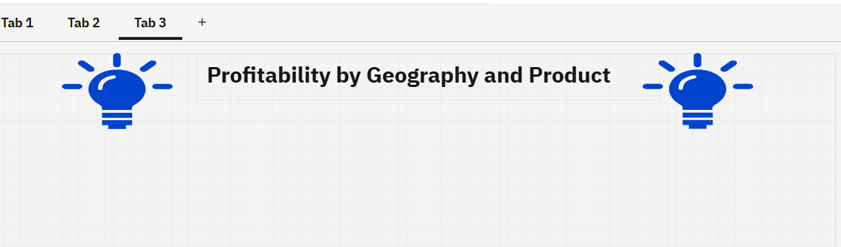

This step is about order region, category& profit. So, heading is given as “Profitability by Geography and Product”.

Two shapes are also used from widgets on both sides.

1. Now adding a Heatmap from visualizations.

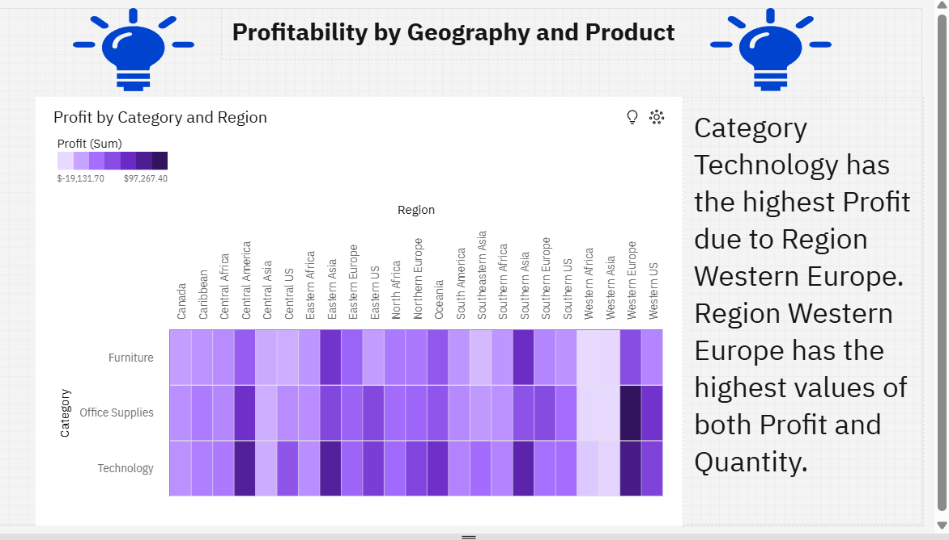

This tab also includes a narrative inside of Heatmap with a title of “Profit by Category & Region.

**X-Axis (Columns):** Region.

**Y-Axis (Rows):** Category.

**Color Intensity:** **Profit**.

1. Now adding two text boxes on this tab from widgets.

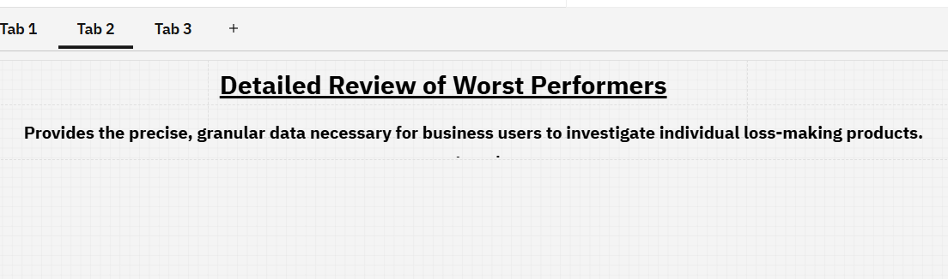

This step is about order Market, Product Name, Quantity & profit. So, heading is given as “Detailed Review of Worst Performers”.

1. Now adding a Table from visualizations.

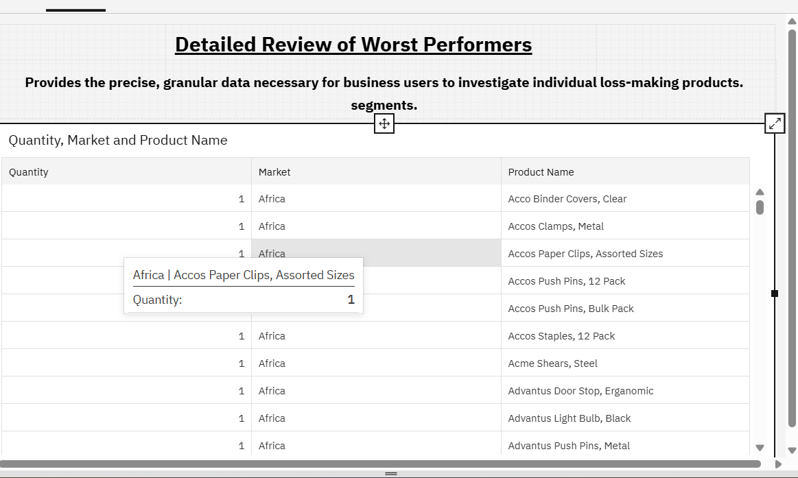

This tab also includes a narrative inside of table.

“Provides the precise, granular data necessary for business users to investigate individual loss-making products or segments.”

**Columns:** Market, Product Name, Quantity

**Sorting:** **Profit**

* **All dashboard tabs with background image & some editing.**

